Joanna Zhang
Professor Chetty and Professor Bruich
ECON 50
1 May 2026

Electchester vs. Pomonok: The Implications of Mitchell-Lama, Union-Linked Housing

Introduction: Questions Surrounding Electchester and Pomonok
Separated by nothing more than Parsons Boulevard, two affordable housing developments in Fresh Meadows, Queens, New York, continue to operate today. Yet, despite sharing the same geographical location, being in walking distance to Queens College, and serving low-income families, they differ drastically in upward mobility. To the left of Parsons Boulevard, Pomonok Houses, created in 1952 by the New York City Housing Authority, has an upward mobility of children’s income into adulthood (at 35 years of age) of 34,000 USD. On the right side of the street, Electchester, created in the 1950s by Local 3 of the International Brotherhood of Electrical Workers, has an upward mobility of children’s income into adulthood (at 35 years of age) of 49,000 USD. As seen in Figure 1, using the Opportunity Atlas, though both housing developments were created in the 1950s and have the same geological location, children who grow up in Electchester earn roughly 14,000 USD more per year in household income at 35 years old in comparison to those raised in Pomonok.
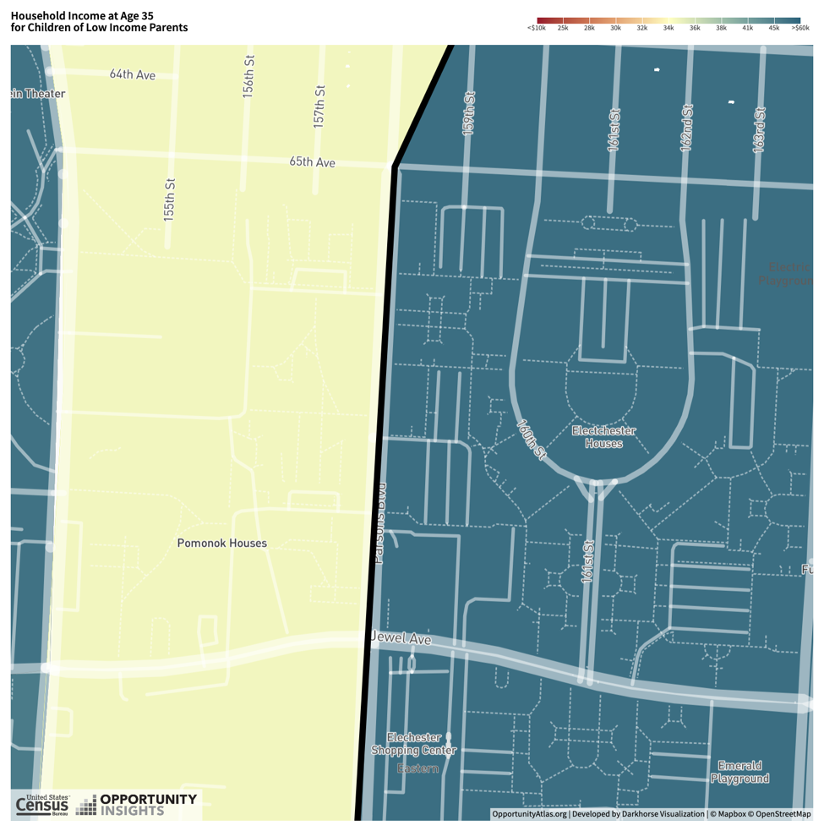
Figure A: Opportunity Atlas Map of Upward Mobility in Children of Pomonok Houses and Electchester Houses’ Low-Income Parents at Age 35
In this research, the upward mobility gap seen in the difference between the Pomonok Houses and the Electchester Houses in Children of Low-Income Parents is explored. Through the analysis of variables and topics studied throughout ECON 50, this research delves deeper into why there is a difference in output from these two affordable housing developments and the core aspects within each community. If both Pomonok Houses and Electchester Houses provide below-market housing, why do children from low-income families experience different adult outcomes?

Historical Analysis: Beginnings of Electchester and Pomonok
The developments were built when the Pomonok Country Club sold its 103-acre property in 1949, with Parsons Boulevard splitting the golf course into halves. The left half was utilized for Pomonok Housing, and the right half was utilized for Electchester Housing. However, it is important to note that while both are very similar in geographical location and community, Pomonok and Electchester differ drastically in their approach to affordable housing. This is primarily because of the historical differences that influenced the missions behind both housing developments.
For instance, Electchester’s mission stems from ideologies of Harry Van Ardale Jr, who was a part of the Joint Industry Board of the Electrical Industry, the union that would go on to purchase half of the golf course's land. The development would include not only 2500 residential units but also a public library, bowling alley, auditorium, and Public School 200. Beyond its facilities, what differentiated Electchester from public housing developments like Pomonok was also its motto of skilled-trade employment and union ties. In other words, residents not only governed the cooperative through elected boards, but the facilities encouraged networking within its residential community.
In contrast, Pomonok’s mission was founded by the New York Housing Authority (NYCHA). It follows the structure of public housing managed by the NYCHA with residents paying subsidized rent. Unlike Electchester’s cooperative structure, Pomonok’s residents do not have elected boards nor forms of governance within the residential decisions. Over time, the infrastructure has declined, and, in 2019, the residents reported issues in living conditions (these included entry locks, unsanitary conditions, etc.).
Through comparing these two developments, because of the different missions and governance, the physical and institutional condition differences between Pomonok and Electchester shape the daily environment of residents. In turn, they may shape the daily environment of children living in these residences and may have lasting consequences into adulthood. It is this context behind the differences in institutional design despite the shared location between Pomonok and Electchester that motivates the causal hypothesis of this research.

Causal Hypothesis and Mechanisms
The causal hypothesis is that the reason why there is a gap in upward mobility between children growing up in Electchester Housing versus children growing up in Pomonok is because of the environmental differences that come with Mitchell-Lama cooperative housing. This housing type provided not only residential stability but also encouraged community bonding, provided safer environments, and union-linked social capital. Because of these factors, there may exist differences in the two communities surrounding cohesiveness, civic engagement, and, above all, economic connectedness. Economic connectedness remains the only form of social capital strongly associated with upward mobility. Some mechanisms that may impact the results seen in this project include residential stability that reduced child displacement, school disruptions, and incarceration rates, economic connectedness, which exposed children to stable career paths, civic engagement that encouraged residential governance and maintenance of Electchester, and labor-market exposures due to the union-backed mission.
Electchester residents have equity stakes in their units, and, with the community and accommodations, they face a lower incentive to leave. This is the aftermath of cooperative ownership structures in affordable housing. The lack of turnover could allow for the friendships and relationships to deepen over time, increasing community engagement activities and community connectedness. Because of this structure, the housing development encourages economic connectedness, a core variable in upward mobility. Residents are not only given housing stability, but with less residential “churn”, children in Electchester are exposed to more working adults with stable employment. They are also given greater social capital through networks to the union and neighborhood ties. Furthermore, the infrastructure includes well-maintained buildings, playgrounds, and schools which not only give children raised in Electchester a better physical environment but encourages the incentive for families to stay.

It must also be noted that, while the Electchester Housing may have greater upward mobility in comparison to Pomonok, results may vary depending on the gender and race of the residents. For instance, the effects of upward mobility may be stronger for male children in Electchester due to the focus being placed on skilled trade (electrical workers). Furthermore, as an area that was initially composed of predominantly white residents, Electchester’s upward mobility may not be representative of the rising Asian immigrant population in Flushing. To understand these possible caveats in the causal hypothesis, we must also explore how mechanisms of cohesiveness, civic engagement, and economic connectedness vary across the variety of demographics that make up the Fresh Meadows, New York area, and what these patterns in the data surrounding incarceration and employment reveal about upward mobility for the female and non-white populations.

Data and Empirical Strategy

This research’s empirical analysis utilizes the tract data from the Opportunity Atlas data (atlas.dta). The goal of the empirical analysis is to find possible connections between children’s upward mobility and the outcomes in the Census tracts. The main variable being tested is the kfr_pooled_pooled_p25, which is the upward mobility of children from low-income families whose parents’ income is in the 25th percentile nationally. To answer questions about the caveats mentioned in the “Causal Hypothesis and Mechanisms” portion, a further examination of race-specific household income rank outcomes across Electchester, Pomonok, and neighboring tracks in Pomonok, Fresh Meadows, Kew Gardens, and Flushing is performed on variables such as
kfr_black_pooled_p25, kfr_hisp_pooled_p25, and kfr_asian_pooled_p25. Furthermore, to address caveats surrounding differences in upward mobility due to gender, this research investigates gender-specific individual income rank outcomes via variable analysis of kir_pooled_male_p25 and kir_pooled_female_p25.
The main empirical strategy of this research is the comparison between the Electchester tract and the Pomonok tract. Further analyses on nearby comparison tracts are also conducted to gauge if differences are specific to just Electchester and Pomonok or if the analysis can be broadened to neighboring tracts as well. The goal of keeping areas being compared geographically close is to ensure that institutions, resident composition, and overall neighborhood social structure are held stagnant across the data analysis. Electchester provides insight into cooperative, union-based housing. On the other hand, Pomonok Housing provides insight into stereotypical affordable-housing models created by institutions like NYCHA.
To test the causal hypothesis, a distributional analysis was done to approximate the overall visual logic of the Opportunity Atlas map and the potential differences between the Electchester tract and other neighboring tracts. Further analysis on variables surrounding higher upward mobility, incarceration rates, and employment outcomes. Through the analysis of tract-level covariates, the research evaluated mechanisms such as poverty, household income, employment, single-parent household share, foreign-born share, and educational attainment. Throughout the research, separate analyses for both race and gender were carried out to highlight aspects in demographic composition across Electchester and Pomonok that may falsify the causal hypothesis. If Electchester’s upward mobility differed across different racial and gender groups, the research would suggest that composition may be a variable that could explain the differences in upward mobility. However, if such upward mobility trends were prominent across all racial and gender groups, the differences in upward mobility could be attributed to more of a place-based mechanism.
It is important to note that despite this analysis, the research cannot prove that Electchester’s environment itself caused higher upward mobility, but such an analysis may be statistically significant enough to hint at possible effects of place-based mechanisms on upward mobility. The goal of this research is to test whether differences in upward mobility are consistent with the causal hypothesis and potentially rule out alternative explanations of the differences in upward mobility between the two tracts, such as demographic differences.

Map Evidence
Using the Opportunity Atlas Maps as a baseline analysis, the research showed differences across demographics (gender and race) in upward mobility advantage for children living in Electchester. While overall, Electchester showed advantages in economic connectedness, the tract showed little to no significant difference in cohesiveness and civic engagement. The Pomonok tract shows 48.6 percent of friends are high income, and the Electchester tract shows 52.2 percent of friends are high income.
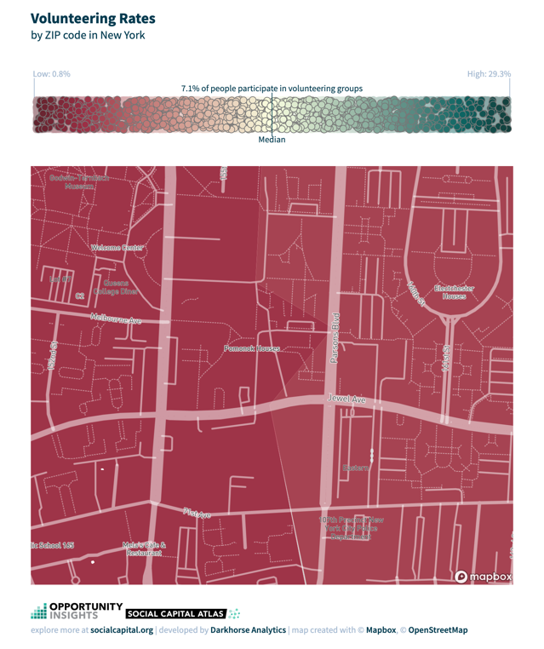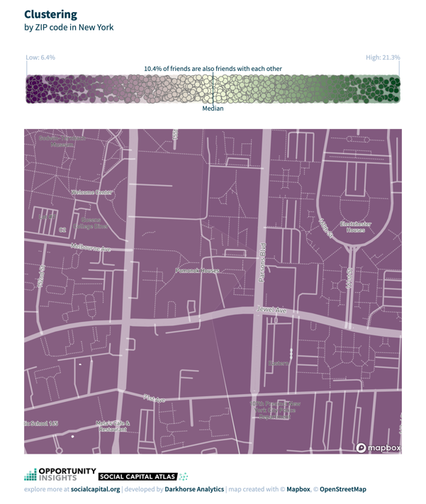
Figure 2: No significant differences across cohesiveness and civic engagement
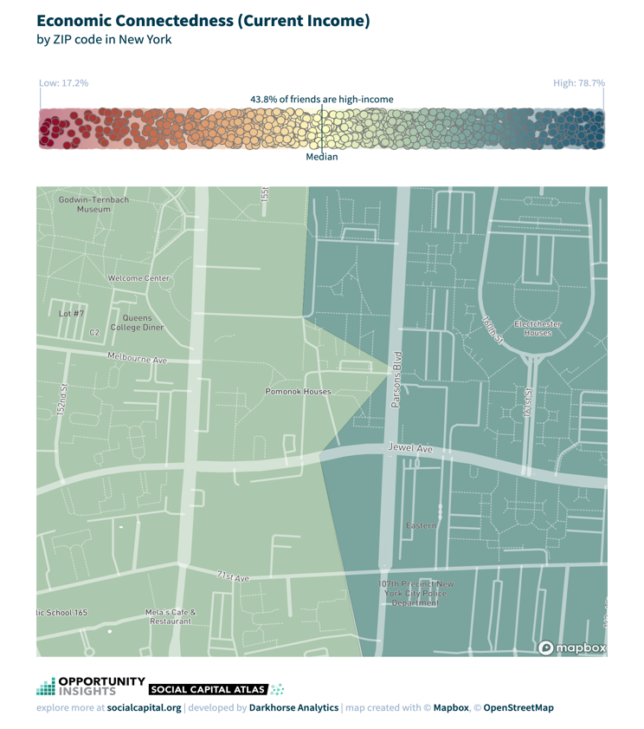
Figure 3: Economic connectedness differences across Pomonok and Electchester

Incarceration Rates
The Opportunity Atlas Maps showed that when it came to incarceration rates, only the black population differed by more than a 1 percent difference between tracts. With the black demographic having the highest incarceration rates, Pomonok Houses tract showed a 7.4 percent rate of incarceration, and Electchester Houses tract showed an 8.9 percent rate of incarceration.
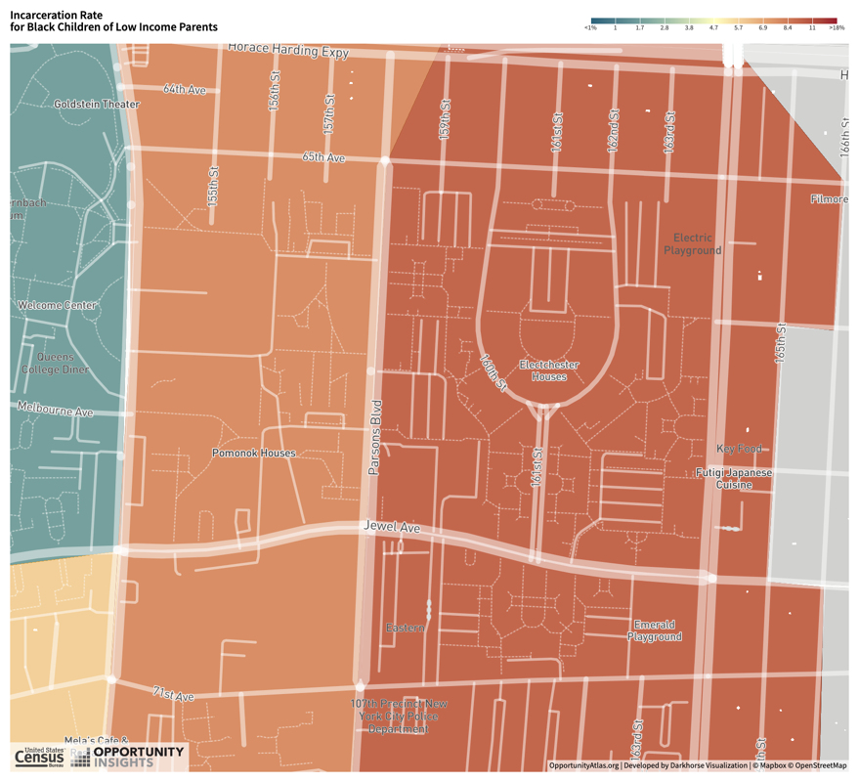
Figure 4: Electchester tract shows a higher incarceration rate amongst Black residents

Gender Differences in Upward Mobility
Upward mobility advantage differences between Pomonok and Electchester did not differ drastically between the female and male children. The difference between Pomonok and Electchester was that for female residents, there was a 12,000 USD difference in income (Pomonok females earning 35,000 USD, Electchester females earning 47,000 USD at the age of 35). The difference between Pomonok and Electchester male residents’ income was 15,000 USD (Pomonok males earning 34,000 USD, Electchester males earning 49,000 USD at the age of 35)
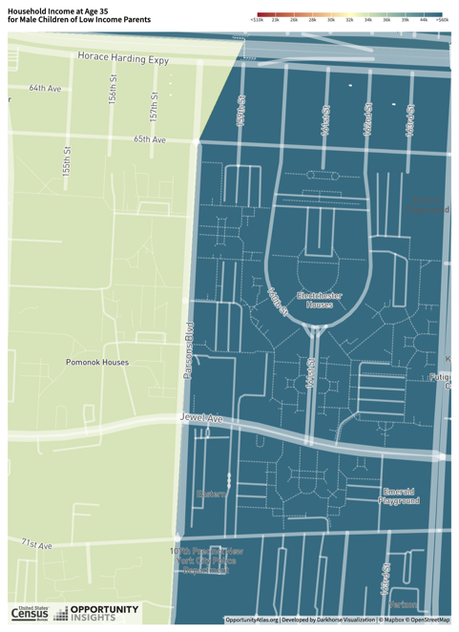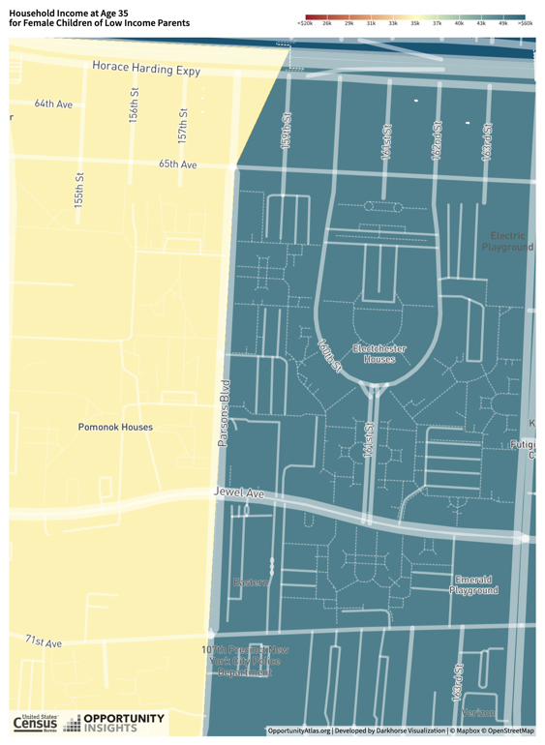
Figure 5: No Significant differences between male and female residents’ upward mobility

Empirical Evidence from R Code

Exploratory Analysis Results
Exploratory Analysis completed at the beginning of the research showed that when mapped on the distribution of upward mobility across Queens’ tracts, Electchester’s upward mobility was around the 54.7 percentile, and Pomonok’s upward mobility was around the 43.0 percentile. This provided evidence that Pomonok lies on the lower end of the Queens distribution of upward mobility, while Electchester sits at a higher position in the distribution. However, Electchester’s upward mobility is not significantly above all Queen’s upward mobility.
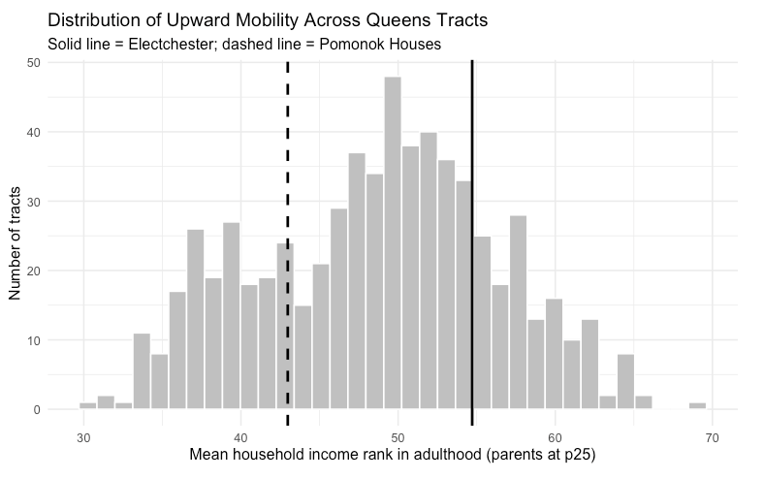
Figure 6: Electchester and Pomonok Upward Mobility in relation to Queens’ Tracts Upward Mobility

Difference-in-Means Table
The difference-in-means table allowed for a brief comparison between outcomes of upward mobility, male and female income, incarceration, employment, and single-parent share across Pomonok and Electchester.
In terms of upward mobility, Electchester had a greater upward mobility, which supported the basis behind the causal hypothesis. Electchester exceeded Pomonok’s upward mobility by a rank of 11.7 points. Data also showed that Electchester was ~2.4 points below the mean of nearby tracts.
In terms of female versus male, Electchester residents had a higher income than Pomonok residents for both female and male demographics. Electchester males had an average individual income rank of 57.976, and Pomonok males had an average income rank of 48.920. Electchester females had an average individual income rank of 53.808, and Pomonok females had an average income rank of 44.729.
In terms of incarceration, the difference-in-mean table showed that Electchester also had a higher employment. Overall, Electchester had an employment rate of .590 and Pomonok had an employment rate of .428.
In terms of variables of poverty share (Electchester = 0.067, Pomonok = 0.286), single-parent share (Electchester = 0.232, Pomonok = 0.641), Electchester had lower rates than Pomonok.

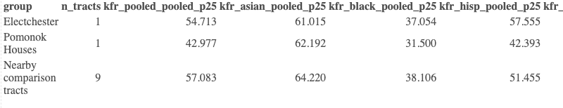
Figure 7: Difference in Mean Tables

Mechanism Evidence
To test the mechanisms of this study, scatterplots were shown in relation to upward mobility against poverty, household income, employment, single-parent share, and college share. When looking at upward mobility vs poverty, the scatter plot showed that the relationship between the two variables was negative. Electchester had a lower poverty rate and higher mobility than Pomonok (see Figure 8) but matched the trend of neighboring Queens tracts. In terms of upward mobility vs household income, the scatter plot showed that the relationship was positive. Electchester outperformed Pomonok in neighborhood income and in upward mobility, but the trend of Electchester, again, matched the trend of neighboring Queens tracts (see Figure 9). In upward mobility vs employment, the scatter plot shows a positive relationship. Electchester sits higher than Pomonok (See Figure 10). In terms of upward mobility vs single-parent share, the relationship in the scatter plot shows that the two variables have a negative correlation. Pomonok has a high percentage of single-parent households and lower mobility (See Figure 11). In terms of upward mobility vs college share, the relationship of the scatter plot was negative, with Electchester being above Pomonok (see Figure 12)

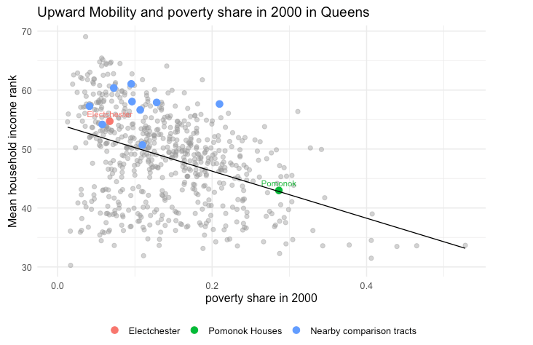
Figure 8

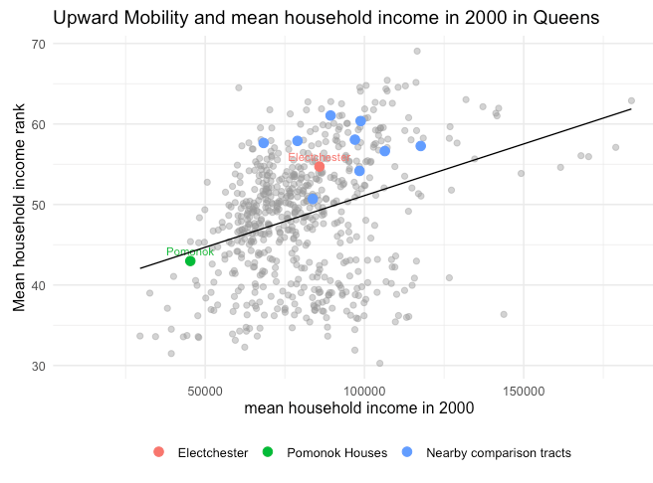
Figure 9
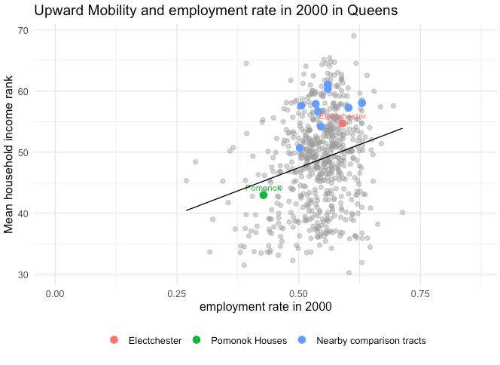
Figure 10
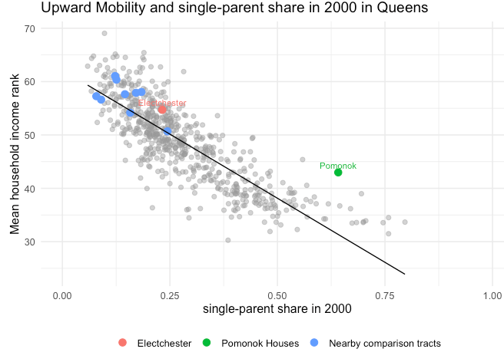
Figure 11
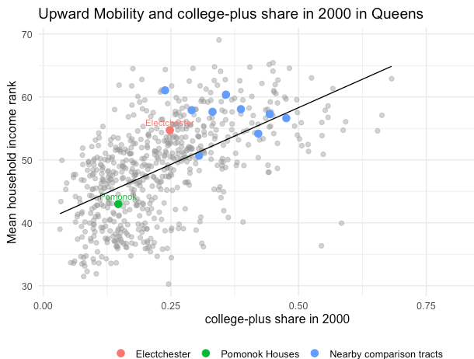
Figure 12

Race and Gender Conditioning
When conditioning on different races and looking at the household income rank, we found the following outcomes. For Electchester, the following income ranks for Asians are 61.015, for Black is 37.054, for Hispanics are 57.555, and for White is 56.101. For Pomonok, the following income ranks for Asians are 62.192, for Black is 31.500, for Hispanics are 42.393, and for White is 56.277. When compared with nearby tracts, nearby tracts show that Asians have an income rank of 64.220, Blacks have an income rank of 38.106, Hispanics have an income rank of 51.455, and White have an income rank of 56.691. Therefore, we see that the biggest income gap is amongst Hispanic across the tracts. In Electchester, the Black demographic has a higher income rank.
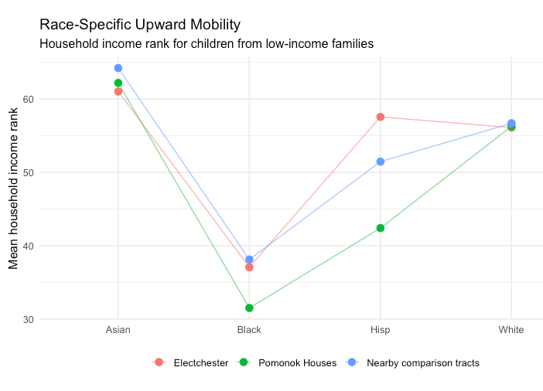
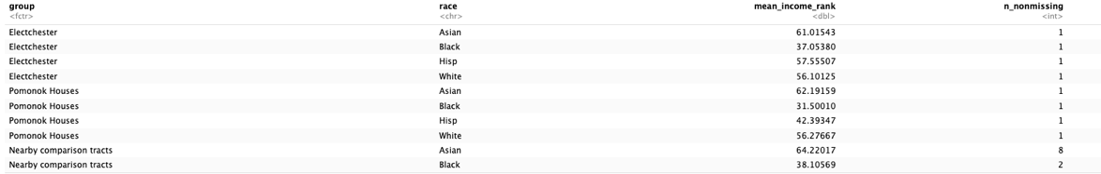
Figure 13: Race Income Rank
When conditioning income rank with gender, we see that Electchester males have an income rank of 57.976, Electchester females have a rank of 53.808, Pomonok males have an income rank of 48.920, Pomonok females have a rank of 44.729, nearby tracts have a male income rank of 55.829, and a female income rank of 58.698.
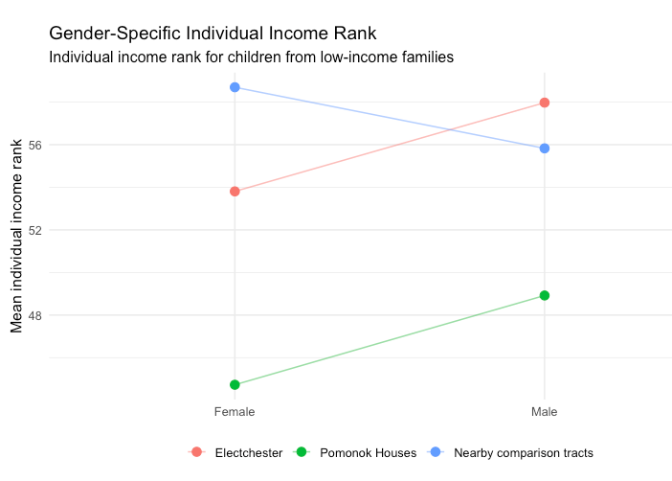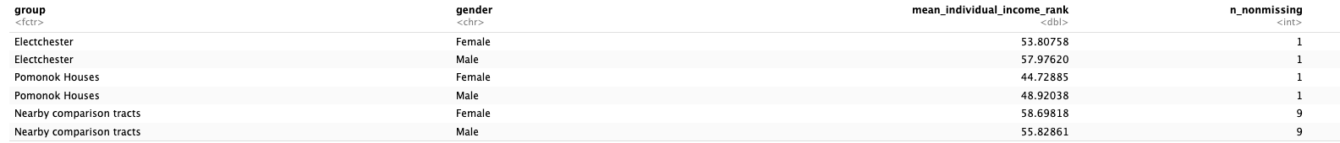
Figure 14: Income Rank Conditional on Gender

Lockbox Validation
The Lockbox Validation shows that the mean adult household income rank is 47.076 for Electchester, 37.006 for Pomonok, and 50.4 percent for nearby tracts. This differs from what we saw in our original results, where Electchester had a rank of 54.7, Pomonok a rank of 43.0, and nearby a rank of 57.1. While Electchester uses the Lockbox Validation, it still outperforms Pomonok; it differs from the original results in that it underperforms in comparison to nearby tracts. Though this does support the basis of our hypothesis, which is that Electchester will have a higher upward mobility in comparison to Pomonok due to its social and housing structure, showing that the advantage Electchester has is unlikely to be attributed to random data noise, the analysis remains specific to a two-tract comparison. Electchester is not outperforming the nearby tracts, so we cannot definitively conclude that Electchester’s performance in Pomonok is due to place-based mechanisms. Results are, therefore, suggestive rather than causal.

Limitations and Caveats
Despite the suggestive patterns in the data and the replicability, there are key limitations and caveats to this analysis. The first limitation is that this data is at the census tract level. This means that while data analysis can be done on how tracts of Electchester and Pomonok differ, it does not look at the children who grew up specifically in Electchester or Pomonok. Rather, the results reflect the outcomes of children in the tract.
The second limitation is that Mitchell-Lama cooperative housing differs in its selection of residents. There are key differences in pre-existing income stability, employment connections, family structure, and more unobserved characteristics. Because this study does not include random assignment into the two housing developments of Pomonok and Electchester, we cannot conclude that any causal relationship between housing environments and upward mobility exists. And the estimates in this analysis are relying on a very small number of tracts, which opens the research up to noisy data.
Finally, the lockbox validation, while allowing us to perform a robustness check, does not conclude that patterns are not driven by data noise. Rather, the replicability in the Electchester and Pomonok gap just strengthens the confidence we have in the data results but doesn’t point towards causal evidence.

Further Study: 2 Methods

Two approaches that could lead to a stronger causal conclusion in this study could be a lottery and waitlist design or a difference-in-differences design. These are two types of studies that were utilized throughout the semester. Their approaches increase causal inference because they attempt to isolate the housing environment effect from omitted variable bias.

The first approach would include a lottery, waitlist design that would replicate some of the natural quasi-experiments seen throughout the semester. Through the lottery, there is a possibility to study differences in families who applied to Electchester and those who are offered housing earlier vs later. Through this study, conditional on the application and eligibility, the timing of receiving a housing offer would be randomized, which would allow the study to look at families who moved into Electchester earlier vs later. Those who accepted the offer earlier will have children who grow up more exposed to Electchester in comparison to those who delayed their offer. The study could then study the long-run outcomes for children in these two groups. This design would increase the causal inference of the Electchester environment on upward mobility.

The second approach would be a difference-in-difference design, where the study could look at the before and after establishment of Mitchell-Lama housing. This study would better examine whether the area that established Mitchell-Lama housing changed the upward mobility of the neighborhoods. The overall data would be the historical Census and data on neighborhoods that established Mitchell-Lama housing over time.

Conclusion

The study shows that children from low-income families have a greater upward mobility in Electchester than in Pomonok. This pattern is replicated across multiple outcomes and passes the lockbox validation sample. This supports the hypothesis that institutional differences in housing development (economic connectivity, social environments, etc.) may influence upward mobility outcomes.

However, the study also raises further questions surrounding the causal effect of Electchester’s environment on upward mobility differences. The main point of evidence for these questions is the performance of Electchester in comparison to nearby tracts.

Yet, the broader implications of what these findings mean in terms of affordable housing policy and design remain. The results support that housing developments that support economic connectedness may be more effective at promoting upward mobility, and that upward mobility within housing developments is not attributed to housing affordability alone. Stronger evidence through further studies is needed. Future studies could include lottery-based designs or difference-in-differences designs, which would provide more evidence towards causal relationships.

